**Experiment: 1**

**Aim:** Write down a program to find out the area of a circle.

**Software:** Dev C++

**Code:**

**#include<stdio.h>**

**#define PI 3.14159**

int main**(void)**

**{**

**double** radius,area;

**printf("**Enter A Radius Of Circle:-**");**

**scanf("**%lf **", &radius);**

**area=** PI * radius * radius **;**

**printf("**Radius = %.2lf cm**\n",radius);**

**printf("**Area Of Circle = %lf sqcm**",area);**

return **0;**

**}**

**Output:**

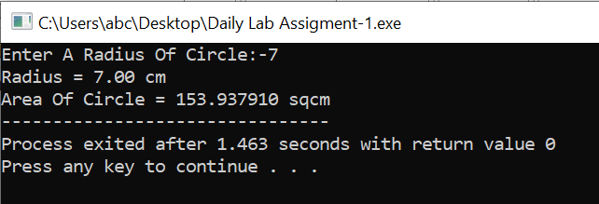

**Experiment: 2**

**Aim:** Write down a program to calculate simple interest.

**Software:** Dev C++

**Code:**

**#include<stdio.h>**

int main**(void)**

**{**

**double** principle_value,rate_of_interset,simple_interest;

**float** time_period;

**printf("**Enter Your Principle Value**:-");**

**scanf("**%lf**",&principle_value);**

**printf("**Enter Your Rate Of Interest**:-");**

**scanf("**%lf**",& rate_of_interset);**

**printf("**Enter Your Time Period**:-");**

**scanf("**%f**",&time_period);**

**simple_interest = (** principle_value * rate_of_interset * time_period **) /100 ;**

**printf("**Principle Value= Rs **%.2lf** /-**\n",**principle_value**);**

**printf("**Rate Of Interest **= %.2f** Percent **\n",**rate_of_interset**);**

**printf("**Time period **= %.2f** Years **\n",**time_period**);**

**printf("**Simple Interest **=** Rs **%.2lf /-",**simple_interest**);**

**return 0;**

**}**

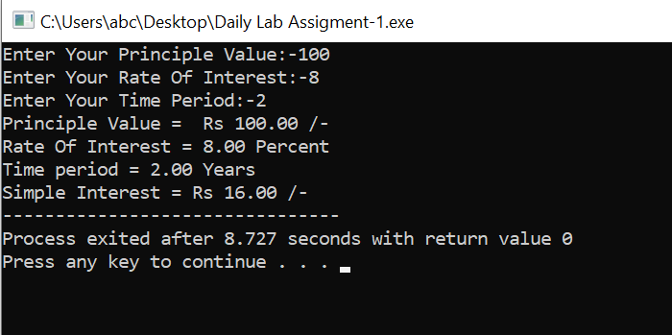**Output:**

**Experiment: 3**

**Aim:**  Write a program to find out the average of three numbers.

**Software:** Dev C++

**Code:-**

**#include<stdio.h>**

int main**(void)**

**{**

**double number,addition=0,average=0;**

**int i;**

**for(i=**1**;i<=**3**;i++)**

**{**

**printf("**Enter A Number**-%d:-",i);**

**scanf("%lf",&**number**);**

**addition =** addition + number **;**

**}**

**average =** addition / (i-1) **;**

**printf("\n");**

**printf("**The Average Is **%.2lf\n",average);**

return **0;**

**}**

**Output:**

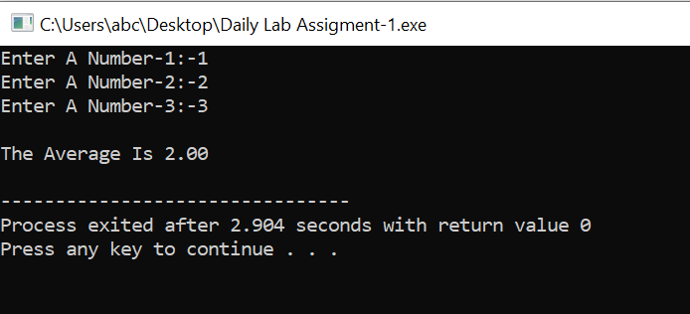

**Experiment: 4**

**Aim:**  Write a program to swap two numbers without using a third variable.

**Software:** Dev C++

**Code:-**

**#include<stdio.h>**

int main**(void)**

**{**

**double** number_1,number_2;

**printf("**Enter The Number-1**:-");**

**scanf("%lf",&**number_1**);**

**printf("**Enter The Number-2:-**");**

**scanf("%lf",&**number_2**);**

**printf("\n");**

**printf("**BeforeSwap**\n**Number-1**=%.2lf\**nNumber-2=**%.2lf",**number_1,number_2**);**

number_1 = number_1 + number_2 ; //a=a+b;//a=30 (10+20)

number_2 = number_1 - number_2 ; //b=a-b;//b=10 (30-20)

number_1 = number_1 - number_2 ; //a=a-b;//a=20 (30-10)

**printf("\n\n");**

**printf("**After Swap**\n**Numbwe-1 **= %.2lf\**nNumber-2 **= %.2lf",**number_1,number_2**);**

**return 0;**

**}**

**Output:-**

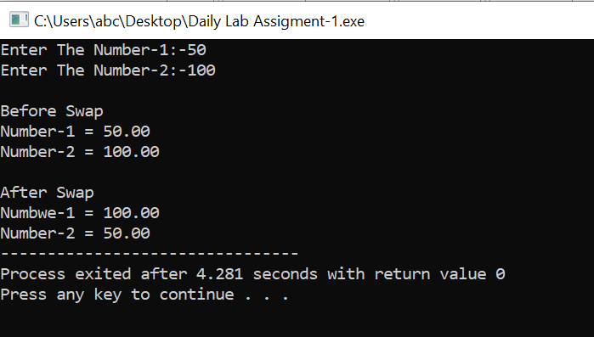

**Experiment: 5**

**Aim:-**  Write a program to multiply two floating-point numbers by using float and double variables.

**Software:-** Dev C++

**Code:-**

**#include<stdio.h>**

int main**(void)**

**{**

**float** number_1,number_2,float_multiplication **;**

**double** double_multiplication **;**

**printf("**Enter A Number-1:-**");**

**scanf("%f",&**number_1**);**

**printf("**Enter A Number-2:-"**);**

**scanf("%f",&**number_2**);**

**float_multiplication =** number_1 * number_2 **;**

**double_multiplication =** number_1 * number_**2 ;**

**printf("**Multiplication Of Flaot In Float Variable **= %f\n",float_multiplication);**

**printf("**Multiplication Of Float In Double Variable **= %f",double_multiplication);**

**return 0;**

**}**

**Output:-**

